Waterfront Accessibility Design Guidelines
Creating an Accessible Waterfront
DRAFT: September 21, 2023

Land Acknowledgement
Waterfront Toronto acknowledges that the land upon which we are undertaking our revitalization efforts is part of the traditional territory of the Mississaugas of the Credit First Nation and that Toronto is covered by Treaty 13 with the Mississaugas of the Credit First Nation.

In addition, Waterfront Toronto acknowledges that Toronto has historically been a gathering place for many Indigenous people, including the Mississaugas of the Credit, the Anishnaabe, the Chippewa, the Haudenosaunee and the Wendat peoples, and is home to many First Nations, Inuit and Métis peoples today.

Message from Our CEO
Accessible Public Spaces Make Better Places for Everyone

Our vision is a vibrant waterfront that belongs to everyone. That vision is only possible through a strong commitment to accessibility in everything we make and do.
Waterfront Toronto is working to create a vibrant, connected waterfront that belongs to everyone. I’m proud to work with a team of city-builders who care about delivering neighbourhoods, parks, destinations, and infrastructure that make people’s lives better and who continually strive to raise the bar on what this means.

A key part of Toronto’s waterfront revitalization is providing safe, easy and enjoyable access for everyone to the shores of Lake Ontario — one of our city’s greatest assets. To date, we’ve created more than 43 hectares of parks and public spaces, and 26 kilometres of trails and promenades making welcoming spaces for leisure, recreation and active mobility. The public spaces we deliver adhere to the Accessibility for Ontarians with Disabilities Act (AODA). But, our goal is to do more than follow the rules — we want to lead the way, just like we have in other areas of our work.

Roughly twenty percent of Torontonians live with a disability. Add to this an aging population and thousands of visitors to our city (and our waterfront) who live with a disability. It’s a staggering number of people who are often unable to fully experience public spaces and the amenities they provide. These figures aren’t just statistics, they represent our family members, friends, neighbours and colleagues.

We’ve developed these Guidelines to support our vision for the waterfront, make a strong commitment to accessibility in the public realm and to make accessibility another area of true design excellence. The document builds on existing standards and provides guidance on elements that are unique to the waterfront, like canoe and kayak launches, gangways and other shoreline amenities. The focus is on eliminating accessibility barriers so people living with disabilities can fully participate in the great public spaces along the waterfront.

The Guidelines will be applied to the design of all new public realm projects under our leadership. We also hope they will serve as a resource for other organizations building public spaces along the waterfront and help cultivate ongoing collaboration between city builders and disability communities.

This is a starting point. We recognize that things change over time – expectations, practices, technologies and policies change. So, we’ve also ensured the Guidelines will be reviewed and updated at a minimum of every three years.

The Guidelines were created in collaboration with the disability community, Waterfront Toronto’s Advisory Committee on Accessibility, and their successful implementation will be supported by a newly formed accessibility advisory committee. We look forward to deepening our knowledge, understanding and relationships with the disability community, to hearing feedback and learning from the initial implementation of the Guidelines to inform future updates. In addition, we will be measuring and reporting back on our success towards our commitments.

I would like to thank the members of our Advisory Committee on Accessibility for working with us to develop these Guidelines. By offering your knowledge and advice, and generously sharing your lived experience, you have given us confidence to take this important step forward.

Table of Contents
A. Context 7
1. Background 8
2. Purpose 9
3. Policy Compliance 10
4. Referenced Standards 11
5. Developing the Guidelines 12
6. Language 13
7. Guiding Principles 14
B. Scope 15
8. Application 16
9. Intended Audience 17
10. Implementation 18
Procurement and Request for Proposals (RFP) 18
Consultation with the Disability Community During the Design Process 18
Post Completion On-Site Review 19
Reporting Success 19
Review and Updates to the Guidelines 19
11. Defined Terms 20
C. Water Access – Making an Accessible Waterfront 24
General 25
12. Docks and Piers 27
13. Gangways 28
14. Canoe and Kayak Launches 29
15. Accessible Swing Lifts into Boats 33
16. Recreational Fishing Nodes 34
17. Water’s Edge Promenade 35
18. WaveDecks 36
19. Boardwalks 38
20. Pedestrian Bridges 40
21. Natural and Urban Beaches 42
D. Livable Communities – Creating Safe and Inclusive Neighbourhoods 43
General 44
22. Enhancement of Complete Streets 46
23. Degree of Sharing Streets 49
24. Curbless Streets 51
25. Curbed Streets 53
26. Green Spaces 59
27. Dogs Off-Leash Areas 60
28. Outdoor Play Spaces 62
29. Amphitheatre Seating 63
30. Lighting 64
31. Wayfinding and Navigation 65
32. Outdoor Furniture 67
33. Public Use Washrooms 68
E. Appendices 69
34. Waterfront Advisory Committee on Accessibility 70
35. Waterfront Accessibility Advisory Committee 71
36. Feedback Process 72

Context

Background

In 2001, the governments of Canada, Ontario and Toronto laid out an ambitious mandate for Waterfront Toronto: to enhance the economic, social and cultural value of the waterfront, and create an accessible and active waterfront for all in a fiscally and environmentally responsible manner.

Providing safe and easy access to the shores of Lake Ontario is a key part of Waterfront Toronto’s revitalization mandate. To date, more than 43 hectares of parks and public spaces and 26 kilometres of trails and promenades have been created in key areas of the waterfront—facilitating active transportation and making it more fun for people to move through the city toward the water’s edge.

Every public space being created or revitalized aims to be accessible according to the Accessibility for Ontarians with Disabilities Act (AODA). This includes recreational trails and beach access routes, outdoor public use eating areas, outdoor play spaces, exterior paths of travel, accessible parking, obtaining services, and maintenance.

In addition to making the waterfront more accessible to everyone, there is a strong focus on ensuring that new neighbourhoods are connected to the existing fabric of the city—with roads, transit service and active transportation routes. These links support the success of local businesses, make the waterfront a better place to live and help realize the vision of one connected waterfront that belongs to everyone.

While significant progress has been made in fulfilling this mandate to date, much more remains ahead. Waterfront Toronto's long-term vision for the waterfront includes more trails and promenades, streets, transit connections and pedestrian bridges, parks and public spaces, and new opportunities to get in, on and over the water.

Purpose

The Waterfront Accessibility Design Guidelines (Guidelines) will help Waterfront Toronto achieve its mandate of creating a vibrant, connected waterfront that belongs to everyone. The Guidelines provide technical specifications that increase the accessibility of waterfront areas and amenities for people with lived experience with disability, of all ages and sizes, caregivers, and many more. The intention is to complement existing legislation and create an enhanced set of Guidelines for waterfront specific features, helping make Toronto’s waterfront one of the most accessible and inclusive in the world.
The Guidelines will be applied to all new Waterfront Toronto public realm projects. (For the purpose of this document, public realm is defined as publicly owned places and spaces that belong to and are accessible by everyone, including parks, open spaces, squares, plazas, sidewalks, streets, etc.) The intent is to promote accessible solutions along Toronto’s waterfront where all people are welcome and encouraged to participate and engage in the enjoyment of the public realm and access to Lake Ontario.
In addition, the hope is that this document may serve as a resource for other organizations building public spaces along waterfronts in Toronto or elsewhere. The Guidelines are also intended to cultivate ongoing collaboration between city builders and disability communities.
While these Guidelines focus on accessibility as it pertains to people with disabilities, they respect and recognize that all people of diverse abilities, ages, socio-economic backgrounds and populations can experience additional barriers and disparities in participating fully in their communities.
These Guidelines were created in collaboration with the disability community, Waterfront Toronto’s Advisory Committee on Accessibility, and will be used in consultation with persons with disabilities through a standing accessibility advisory committee.

Policy Compliance

Over the years Waterfront Toronto has complied with all relevant accessibility policies and practices. In 2014, per the requirement of the AODA, Waterfront Toronto developed a Five-year Accessibility Plan (also referred to as the Multi-Year Accessibility Plan 2014-2018).

In 2017, under the Design of Public Spaces Standards (Ontario Regulation 413/12, made under AODA), Waterfront Toronto committed to meet new requirements related to obtaining services and maintaining accessible parts of public spaces. The Design of Public Spaces Standards under the Integrated Accessibility Standards Regulation (IASR) requires that newly constructed or redeveloped public spaces, including recreational trails, beach access routes, outdoor public use eating areas, outdoor play spaces, exterior paths of travel, accessible parking, obtaining services and maintenance are accessible. In addition, Waterfront Toronto aims to comply with and exceed, where applicable, the minimum requirements for barrier-free design as per the Ontario Building Code.

Since 2018, Waterfront Toronto has maintained all accessibility practices and fine-tuned them to align with feedback to ensure ongoing identification, removal, and prevention of accessibility barriers. Waterfront Toronto continues to provide an Accessibility Compliance Report, as required, to ensure compliance with the IASR under the AODA.

Referenced Standards

The Waterfront Accessibility Design Guidelines build upon existing standards, including those that exceed minimum legislation such as the City of Toronto’s Accessibility Design Guidelines, and highlight requirements that are specific to Toronto’s waterfront and that are not covered in other standards. In most instances, requirements in the Guidelines will exceed the minimum legislated requirements in the Ontario Building Code (OBC) and the Accessibility for Ontarians with Disability Act, Design of Public Spaces Standards.

Given the waterfront’s unique landscape, some elements in this document cover features that are specific to the waterfront and are not covered in other documents. Where conflicts exist between the requirements of these Guidelines and legislations enacted by the federal or provincial government, the highest level of accessibility requirements must apply.

In addition, the Guideline builds upon the following standards:
- Ontario Building Code (LINK)
- Accessibility for Ontarians with Disability Act, Design of Public Spaces Standards (LINK)
- City of Toronto’s Accessibility Design Guidelines (LINK)
- City of Toronto’s Complete Streets Guidelines (LINK)
- City of Toronto’s Standards for Designing and Constructing City Infrastructure (LINK)
- City of Toronto’s Construction Specifications and Drawings for Roadworks Engineering Standards for Roadways (LINK)
- CAN-ASC-2.1 Outdoor spaces: Public Review Draft - Accessibility Standards Canada (LINK)

These Guidelines acknowledge that the Ontario Human Rights Code (OHRC) has primacy or takes precedence over all other legislation in Ontario unless that legislation specifically states that the OHRC does not apply.

It is recognized that in addition to the requirements in these guidelines, safety standards would also need to be met.

Developing the Guidelines

In spring 2021, Waterfront Toronto issued a request for proposals seeking consultants with specialized design expertise to help draft the Waterfront Accessibility Design Guidelines. Human Space, the inclusive design practice at BDP Quadrangle, was the successful proponent. In addition to their many credentials, Human Space was involved in co-creating the City of Toronto Accessibility Design Guidelines.

In keeping with Waterfront Toronto's commitment to ongoing engagement with the disability community, the Waterfront Accessibility Design Guidelines were developed in collaboration with the disability community. This process was led by Human Space, working closely with Waterfront Toronto’s Advisory Committee on Accessibility (ACA). The ACA were a group of individuals selected based on their professional, technical and/or their lived experience with disability. The ACA’s mandate was to provide guidance and direction to Waterfront Toronto on how to achieve leading standards for accessibility along the waterfront. More information about the ACA is provided in Appendix.

Language

Waterfront Toronto uses person-first language, modeled on the language used in the Accessible Canada Act and Committee on the Rights of Persons with Disabilities. The usage of person-first language is intentional and meant to convey respect, dignity, and value while moving away from labelling, stereotyping, and discrimination.

Guiding Principles

The following guiding principles were established in collaboration with the ACA and reflect the intentions of the Waterfront Accessibility Design Guidelines and its implementation by Waterfront Toronto in delivering its projects:

- Nothing Without Us:
- Collaborating with the disability community in an Inclusive Design Process.
- Considering the full range of human diversity.
- Promoting diverse participation (designers and users) and including individuals who have lived experience, especially persons with disabilities, in decision making that impacts their lives and the environment around them.

- Raising the bar for diversity and inclusion by:
  - Eliminating and preventing barriers for people with disabilities.​
  - Creating environments where all people can participate.
  - Filling gaps in existing legislation and therefore exceeding minimum requirements.

- Promoting wellness​ by:
- Creating opportunities for people with disabilities to easily access the restorative power of nature.
- Upholding standards of health and safety​.
- Enabling participation to create a sense of belonging.

- Pursuing design excellence ​by:
- Establishing thoughtful and integrated design solutions.
- Designing high quality and durable interventions.
- Proving that beauty and accessibility can be achieved together in public spaces.

Scope

Application

The Guidelines provide specifications and requirements for elements and conditions that are unique to waterfront sites. The Guidelines are applicable to public realm projects being undertaken by Waterfront Toronto and our agents (e.g., design consultants, construction managers, etc.), including new construction and projects that have reached the end of their lifecycle or require upgrades (excluding state of good repair). They may also be used as toolkit and reference by others who wish to enhance the accessibility of public realm projects in their area.

Intended Audience

The Guidelines are intended to be used by Waterfront Toronto and its public realm design and delivery teams (e.g., landscape architects, planners, designers, accessibility consultants) in consultation with persons with disabilities.

Implementation

Waterfront Toronto’s commitment to creating accessible and inclusive environments includes the following implementation strategies:

Procurement and Request for Proposals (RFP)
RFPs for the procurement of services will identify Waterfront Toronto’s commitment to accessibility and the Waterfront Accessibility Design Guidelines and will outline the responsibility of the selected service provider to apply the Guidelines in fulfilling their scope of work along the waterfront, where applicable. Service providers will also be required to deliver all public-facing presentation materials and reports in compliance with the Accessibility for Ontarians with Disabilities Act, Information and Communications Standards.

RFPs procuring services specific to the design of public spaces will include a requirement for an accessibility consultant as a mandatory member of the project team. The role of the accessibility consultant is to review and advise on the technical requirements related to accessibility and lead the project engagement with Waterfront Toronto’s Waterfront Accessibility Advisory Committee (see below for details). The accessibility consultant does not replace the consultation process with the disability community but rather supports the project team through an engagement process. RFPs will note that Waterfront Toronto encourages accessibility consultants to be persons with disabilities.

Consultation with the Disability Community During the Design Process
Waterfront Toronto will convene a standing committee, the Waterfront Accessibility Advisory Committee (the Committee), comprising members who represent advocacy or professional organizations, and individuals with relevant expertise, most of whom will be persons with disabilities, as defined by Accessibility for Ontarians with Disabilities Act. The mandate of the Committee will include providing feedback, guidance, and advice to project teams and accessibility consultants when reviewing public realm related projects, as well as reviewing and recommending amendments to the Waterfront Accessibility Design Guidelines. Public realm projects including new construction and projects that have reached the end of their lifecycle or require upgrades being led by Waterfront Toronto will be reviewed by the Committee early in the design process (i.e., Schematic Design Phase) and additionally, if requested by the Committee. The Committee’s comments will also be shared with the Waterfront Toronto Design Review Panel during its review of projects.

In cases, where the new elements are being implemented and guidance has not been provided in the Waterfront Accessibility Design Guidelines, the project team and accessibility consultant are expected to engage in a co-design session with the Waterfront Accessibility Advisory Committee to explore the ideas and potential gaps related to accessibility. Findings should be considered for future updates to the Waterfront Accessibility Design Guidelines.

Post Completion On-Site Review
Upon completion of each project subject to the Guidelines and reviewed by the Committee, the Waterfront Accessibility Advisory Committee will be invited to complete a post occupancy on-site review (accessibility roll-through) of the project. The intent of the accessibility roll-through will be to highlight lessons learned that can be applied to future projects and updates to the Waterfront Accessibility Design Guidelines.

Reporting Success
Waterfront Toronto will report on outcomes to the Waterfront Accessibility Advisory Committee and to the public through its Integrated Annual Report.

Review and Updates to the Guidelines
Waterfront Toronto recognizes that accessibility best practices continue to evolve and change and expects that the Waterfront Accessibility Design Guidelines will be updated regularly. All members of the public, including Waterfront Toronto’s consultants, partners as well as stakeholders, are encouraged to provide feedback and suggest changes to be considered for future updates – additions, deletions, or corrections – by completing the Feedback Process included in the Appendices.

The Waterfront Accessibility Design Guidelines will be reviewed at minimum every three years by Waterfront Toronto staff in consultation with the public, and the Waterfront Accessibility Advisory Committee. Periodic updates will reflect lessons learned through implementation, changes to legislation, regulations, and standards as well as new technologies and information that ought to be considered at the time. Where there is conflict between requirements found in the Waterfront Accessibility Design Guidelines, and the Referenced Standards, Waterfront Toronto staff will comply with the highest requirements of accessibility.

Defined Terms

Accessible Path of Travel: A continuous, unobstructed route providing exterior and interior access to elements and spaces. Exterior accessible paths of travel include sidewalks, trails, pathways, boardwalks, beach access routes, pedestrian overpasses and underpasses, exterior paths of travel to entrances and exits, ramps, pedestrian crossings, traffic islands, curb ramps, depressed curbs, and access aisles. An accessible path of travel should be safe, unobstructed and the most direct route. See Pedestrian Clearway and Sidewalk. (Source: City of Toronto’s Accessibility Design Guidelines)

Accessible Swing Lifts: A rail system made of weather and waterproof material. It is designed for use at waterfront settings and adjacent to indoor or outdoor swimming pools, where the intention is to provide persons with disabilities with opportunities to enjoy vessels, watercrafts, water sports and other water-based activities. Accessible swing lifts may be most beneficial for smaller motorized vessels and can be used with privately owned or public vessels or watercraft.

Amenity: A useable and useful feature of a public space (i.e., water fountain, canoe or kayak launch, benches, etc.).

Amphitheaters: An open-air venue that allows large numbers of people to be together in tiers of seats for a presentation of an event or for a gathering.

Boardwalks: An elevated path of travel typically made of wood that enables users to cross beaches or waterfronts, wet, fragile, or marshy land.

Canoe and Kayak Launches: Can be added or integrated to a dock featuring an open pocket, which holds a canoe or kayak above the water surface and allows users to push the canoe or kayak onto it with ease. It allows users to easily enter a canoe or kayak. Once settled, users can grab the paddles and push off onto the water by paddling.

Colour Contrast: The degree of difference between one colour and another on the colour wheel. The more visually different the colours are the greater the contrast. Brightness contrast is the difference between one object or surface and another. The greater the difference in brightness levels, the greater the contrast. Colour/brightness contrast assists in identifying key elements in the built environment and aids in wayfinding.

Colour/brightness contrast of key elements in the built environment must be at least 50 percent, whereas the colour/brightness contrast on signs and pictograms must be at least 70 percent. Colour/brightness contrast is measured through light reflectance values (LRV) and comparing the adjacent colours’ LRV. (Source: City of Toronto’s Accessibility Design Guidelines)

- Colour contrast = [(B1-B2) x 100] / B1
  - B1: Colour One
  - B2: Colour Two

Curbed Streets: A roadway that has a raised edge or rim. Curbed streets typically provide a low degree of sharing between pedestrians, cyclists, and vehicles who occupy space at any given time along the street.

Curbless Streets: A roadway that does not have a raised edge or rim. Curbless streets typically provide a high degree of sharing between pedestrians, cyclists, and vehicles who occupy space at any given time along the street. They also include design features to ensure ease of movement and safety for all users.

Degree of Sharing: The concept of the “degree of sharing” refers to the extent that pedestrians, cyclists, and vehicles share spaces or occupy space at any given time along the street.

Docks and Piers: A dock is a structure extending along a waterfront or out from the shore into a body of water, to which boats may be moored or tied up. A pier is a transitional structure or platform that rises above a body of water and usually extends from the shore providing above-water access to offshore areas.

Dynamic Symbol of Access: Aims to improve the International Symbol of Access, also known as the international wheelchair symbol, by using a more dynamic figure. It is used to indicate where accessibility has been provided at a site, building or other facilities for persons with disabilities.

Gangways: A platform, walkway or a ramp used to board or disembark from boats.

Green Spaces: Green spaces along Toronto’s waterfront may range from smaller urban parks such as Aitken Place Park to larger reclaimed and naturalized areas such as the future Don River naturalized riverway as part of the Port Lands Flood Protection Project.

Leading Edge: The beginning and end of a ramp or sloped surface.

Natural Beach: The shore of a body of water covered by sand, gravel, or large rock fragments.

Dog Off-Leash Areas: An enclosed or fully fenced exterior space where owners can bring their dogs to play with other off-leash dogs.

Outdoor Play Spaces: Any designed and/or constructed structures or spaces that children are expected to use for play. These may include but are not limited to natural areas, such as areas that contain logs, rocks, sand, or water, constructed play areas, areas for water or sand play, climbing facilities, spray pads/spray parks/splash pads and swings.

Pedestrian Bridges: Pedestrian bridges span bodies of water typically over the slips located along the waterfront.

Recreational Fishing Nodes: An outcropping at the water’s edge providing a space for recreational fishing, bird watching or for resting and enjoying nature.

Schematic Design: The 30% design phase of the project. This stage includes drawings that offer an overview of the project’s features and layout.

Sound Beacons: A navigation device for persons with low to no vision. The device emits periodic sound that allows persons with low to no vision to locate a key destination. For example, the primary accessible entrance to a building, service counter, or universal washroom. These devices can be installed at doorways of buildings, public transit entry doors, traffic lights, etc. The system is "last meters solution" and works on audible distances less than approximately 5 meters.

Tactile Attention Indicators (TAI): Shaped as truncated domes, which communicate an upcoming hazard or decision-making point. (Source: City of Toronto’s Accessibility Design Guidelines)

Tactile Direction Indicators (TDI): Parallel fat-top elongated bars, which communicate a suggested path of travel and act as a tool to help with wayfinding. (Source: City of Toronto’s Accessibility Design Guidelines)
Urban Beach: Artificially created environment in an urban setting that simulates a beach front through sand.

Waterfront Toronto Design Review Panel: Includes leading architects, urban planners, landscape architects, and other professionals from Canada and abroad, who meet on a monthly basis to provide input at key stages of a project’s design process.

Water's Edge Promenade: The continuous network of public realm spaces along the Toronto waterfront that prioritizes the accessible and safe movement of people.

WaveDeck: An iconic landmark element along the water’s edge. The WaveDecks are urban docks that act as both a piece of art and a functional gathering space. They feature creative undulating forms with varying changes of level that include an accessible experience.

Water Access – Making an Accessible Waterfront

General

Providing safe and easy access to the shores of Lake Ontario is an important part of Waterfront Toronto’s work. The vision for the central waterfront includes creating a continuous Water’s Edge Promenade linked with pedestrian bridges, an urban tree-lined promenade and WaveDecks at the heads-of-slips as well as a series of floating elements that encourage marine activity and offer new public experiences in relation to the lake. To date, Waterfront Toronto has created over 26 kilometers of trails and promenades in key areas of the waterfront along with three WaveDecks at the heads of the Spadina, Rees, and Simcoe slips, an urban beach, and a recreational fishing node.

Intent
To provide ease of access to the water’s edge and its amenities.

Operations and Ongoing Maintenance
Operations and Maintenance plans will be developed in collaboration with the City of Toronto and others as part of the design process. The plans will consider items such as canoe and kayak launches, and temporary paths of travel, such as a portable non-slip beach access mats, snow, and ice removal, etc., to ensure they remain in good working order. Plans will also consider inspections to be completed following inclement weather in case of significant changes in water levels. Temporary paths or fixtures must be inspected to ensure that they remain usable and are clear of any obstructions.

Guidance
In addition to the guidance provided in the TADG (LINK) on:
- Trails, Pathways, Boardwalks, and Beach Access Routes (1.1.2)
- Exterior Accessible Paths of Travel (1.1.1)
- Grade and Elevation Changes (1.1.6)
- Handrails (1.1.7)
- Guards (1.1.8)
- Exterior Ramps (1.1.9)
- Exterior Stairs (1.1.10)
- Obstructions, Protrusions and Overhead Objects (1.1.11)
- Safety and Security (1.1.12)
- Docks, Sea Walls and Piers (1.4.9)
- Waterfront Areas (1.4.10)

The following requirements must be considered for new construction to the public realm and projects that have reached the end of their lifecycle or require upgrades (excluding state of good repair).

Docks and Piers

- Provide accessible paths of travel.
  - Toe kicks that are a minimum of 75 mm above the finished ground surface and have colour contrast from the surrounding environment must be provided where the accessible path of travel is intended to be parallel to the water.
  - Guards combined with handrails that comply with TADG, Guards (1.1.8) and Handrails (1.1.7), must be provided where the accessible path of travel is intended to be perpendicular to the water.
  - Provide a clear turning circle at least 2500 mm where boat mooring occurs on docks.
  - Provide a ramp that complies with TADG, Exterior Ramps (1.1.9) and that has a slope not steeper than 1:15 (6.7%) or a gangway. See section 13 Gangways.

- Provide equipment to enhance safety on a floating dock.
  - Safety and lifesaving equipment such as ladders, ring buoys, and safety hooks must be provided and safely located outside of the accessible path of travel, but close to the edge of the floating dock.

- Provide identification of dock edge.
  - A colour contrast or a distinctive visual pattern to demarcate that is a minimum of 50 mm. The strip must extend across the entire length of the dock edge except where a guard or handrail is provided as a barrier.

- Provide shade, shelter, and seating.
  - Shade, and shelter that complies with TADG, Obstructions, Protrusions and Overhead Objects (1.1.11) must be provided.
  - Seating that complies with TADG, Rest Areas (1.1.5) and Benches and Seats (1.5.1) should be provided, if feasible.
  - Provided at a range of viewing areas that are located within proximity to key destinations along docks and piers.

Gangways

- Provide accessible connection points between the boardwalk or water’s edge structure to a water-level floating dock.
  - The slope of the gangway must be calculated on the lowest water level mark typically expected in the summer season.
  - The slope of the gangway during the lowest water level mark must be no steeper than 1:15 (6.7%).
  - A clear width at least 2500 mm must be provided between the interior edge such as between handrails and toe rails.
  - A 2500 mm turning circle must be provided on landings.
  - Where possible, landings should be provided not more than 9 metres apart along the gangway.
  - Where possible, a maximum 1:15 (6.7%) running slope should be provided.

- Provide accessible features on the gangway, like typical elements found on a ramp.
  - At the top and bottom of the gangway:
    - Colour contrast or a distinctive visual pattern to demarcate between the incline and level portions of the gangway must be provided to help identify the change in level.
    - A tactile element, but not tactile attention indicators, must be provided as a textural cue that there is a change in level.
  - Handrails and edge protection that comply with TADG, Handrails (1.1.7) must be provided on both sides of the gangway.

Canoe and Kayak Launches

- Provide accessible entry points into non-motorized vessels such as canoes and kayaks, included adapted canoes and kayaks.
  - At every project where launch sites are proposed, at least 50% of the total launch sites, but never less than one, must include an accessible launch.
  - An accessible path of travel must connect to the accessible launch point.
  - Provide colour contrast or a distinctive visual pattern to demarcate the leading edge of the entry point.

- Accessible canoe and kayak launches must:
  - Be provided in safe locations.
  - Include grab bars, custom or off-the-shelf products.
  - Include a transfer bench.
  - Include a railing that extends 450 mm beyond the edge of the dock and over the watercraft for added stabilization when entering and exiting a watercraft.

- Where an accessible canoe or kayak launch is not provided, a portable transfer bench or chair must be provided to allow independent or assisted transfers for users into boats.
- The portable transfer bench or chair must be light weight and have adjustable handles permitting transfers from the height of a mobility device.

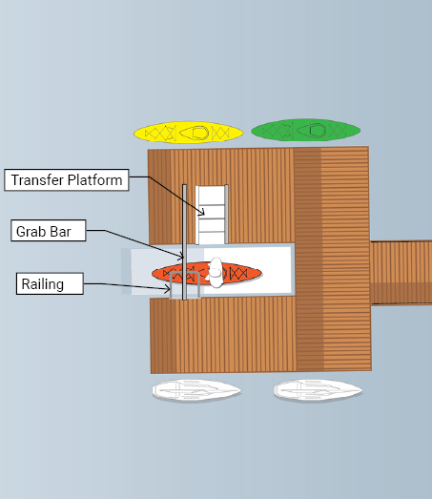
Figure 1: Canoe/Kayak Launch
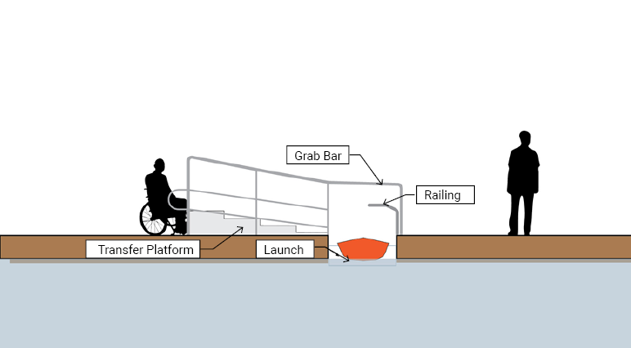
Figure 2: Canoe/Kayak Launch

Accessible Swing Lifts into Boats

- Provide accessible swing lift where gangway entry into vessel is not possible.
  - A minimum of one accessible swing lift, custom or off-the-shelf product, must be provided at each port that can be accessed by a range of vessel sizes.
  - The accessible swing lift must be served by an accessible path of travel.

- Where accessible swing lifts into boats are not provided, a transfer bench or other portable transfer chair should be provided to allow independent or assisted transfers for users into boats.
  - The portable transfer bench or chair must be light weight and have adjustable handles permitting transfers from the height of a mobility device.

Recreational Fishing Nodes

- Provide access to recreational fishing nodes.
  - All recreational fishing nodes must have an accessible path of travel to the fishing area and other amenities (i.e., companion seating or waste receptacles).
  - Where guards are provided that comply with TADG, Guards (1.1.8), at least 40% of the guards must be a maximum of 800 mm high to facilitate fishing and other activities by persons using mobility devices or persons of short stature.

- Provide a range of accessibility equipment at fishing nodes.
  - Adaptive fishing equipment must be provided to assist people in holding and operating a fishing rod, such as a rod holders mounted at maximum 1100 mm high, where guards are used.
  - Where fishing equipment may be rented out by the public, accessible equipment should be available and include reel cranks to allow for a solid grip, magnetic tip threaders to pull the tip of a line through the eye of a hook instantly, high visibility bobbers, or easily attachable lures and flies.

Water’s Edge Promenade

  - Provide pedestrians with a minimum clear width of 3.0 metres.
- Any outdoor amenities or elements, such as furniture, plantings, waste and recycling receptacles, bicycle racks or moveable and temporary items, must be located outside of the pedestrian clearway.

  - Provide rest areas at a maximum of 30 meters apart and evenly distributed along the promenade.
- Companion seating and clear ground space for persons using mobility devices, service animals, and strollers that comply with TADG, Benches and Seats (1.5.1) must be provided.
- Provide a range of viewing areas that are located within proximity to key destinations along the water’s edge promenade.

WaveDeck

- Provide an accessible path of travel.
- An accessible path of travel must be integrated as a part of the WaveDeck experience.
- An accessible path of travel along a WaveDeck must be continuous and extend along the full extent of the water’s edge.
- The accessible path of travel must be delineated through textural cues, colour, and the Dynamic Symbol of Access.

- Design with accessible features.
- Where there are changes in level, the terraced steps must be designed to be visible and include elements such as:
    - A colour contrast or a distinctive visual pattern to demarcate the leading edge of the tread.
    - Cane detectable guards that comply with TADG, Guards (1.1.8) must be provided around the perimeter of the terrace steps that are steeper than 1:15 (6.7%) slope for the accessible path of travel.
- Guards that comply with TADG, Guards (1.1.8) must be provided along the edge of anyWaveDeck that is immediately adjacent to the water.
- Toe kicks that are a minimum of 75 mm above the finished ground surface must be provided along the Water’s Edge Promenade that leads to the WaveDeck.

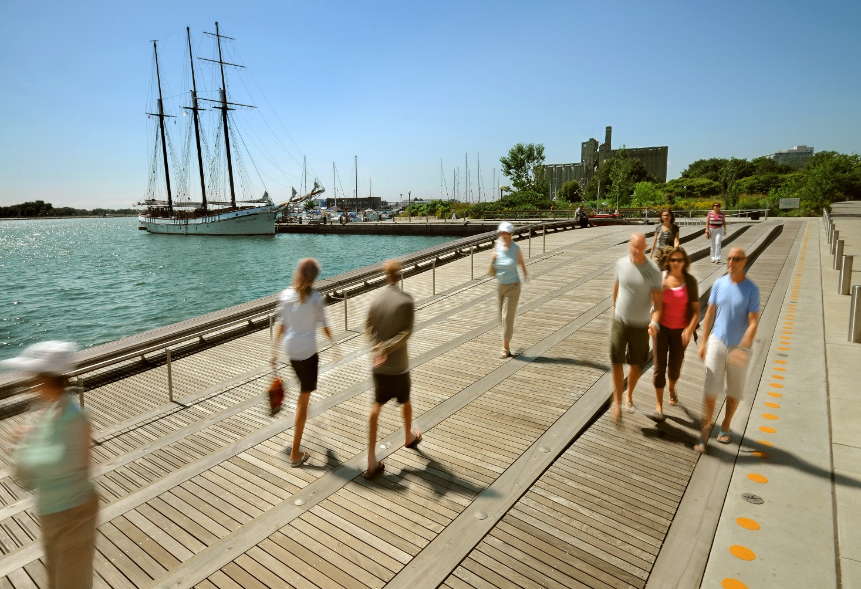Image 1: Spadina WaveDeck

Boardwalks

- Provide accessible paths of travel.
  - Boardwalks must provide a minimum clear width of 3.0 metres to allow for a buffer at the water’s edge and passing space for people using mobility devices. Seating, site furnishings and plantings must be located outside of this clear width.
  - Toe kicks that are a minimum of 75 mm above the finished ground surface must be provided where the accessible path of travel is intended to be primarily parallel to the water.
  - Guards that comply with TADG, Guards (1.1.8) must be provided where the accessible path of travel is intended to be perpendicular to the water.
  - A ramp that complies with TADG, Exterior Ramps (1.1.9) must provide a running slope not steeper than 1:15 (6.67%) where the boardwalk is at a lower level than the dockwall.
  - Ramps must be located not more than 45 metres apart.

- Enhance safety measures.
  - In addition to the existing marine standards and requirements, additional safety measures must be considered to assist people who have fallen into the water while they are waiting for assistance to arrive For example, elements such as additional drop-down ladders, safety buoys, or designated safety floating docks with ladders in the water that people can access while waiting for help.

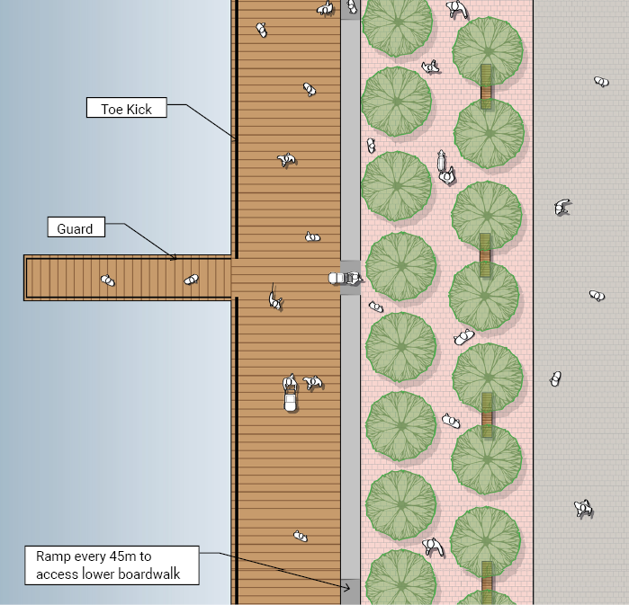
Figure 3: Boardwalk

Pedestrian Bridges

- Provide accessible paths of travel.
  - Where feasible accessible paths of travel on pedestrian bridges must be clearly delineated and separate from cyclists’ paths and include elements such as:
    - Lane dividers.
    - Pavement markings and signage indicating pedestrian and cyclist paths of travel.

  - Accessible paths of travel must be designed to be as level and direct as possible or be a maximum of 1:20 (5%). Where a level or sloped accessible path of travel cannot be provided, a ramp with gradual transitions must be provided.

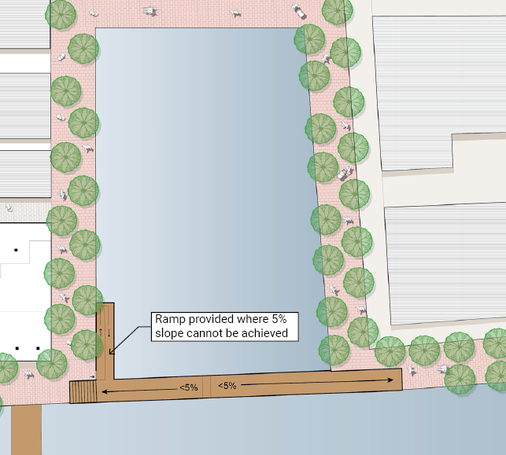
Figure 4: Pedestrian Bridge

Natural and Urban Beaches

- Provide accessible paths of travel into the water at low and high tide, where feasible.
  - Accessible paths of travel must be permanent, firm, level and stable and be made of products such as concrete or a wood plank boardwalk.
  - Where accessible paths of travel cannot be permanent, a temporary path of travel such as a portable non-slip beach access mat must be provided.

- Connect amenities on the beach.
  - Accessible paths of travel must lead to the water’s edge and to a minimum of one of each type of amenity offered on the beach.
  - Typical amenities at beaches should include shade structures, seating, waste receptacles, and access to accessible washrooms, drinking fountains and water bottle filling stations.

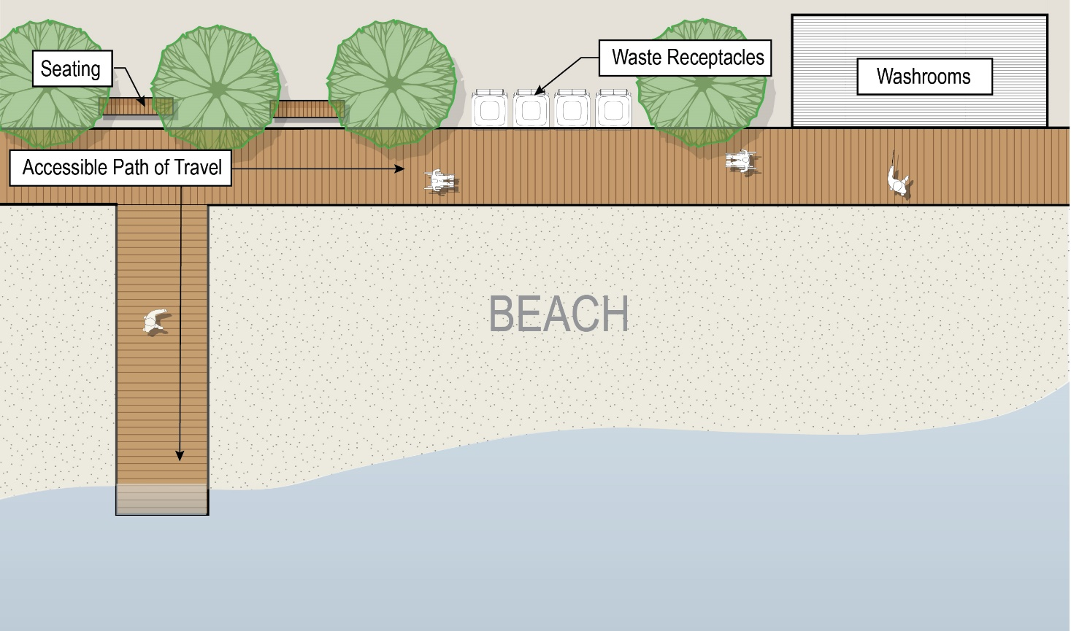Figure 5: Natural Beach

Livable Communities – Creating Safe and Inclusive Neighbourhoods

General

Waterfront Toronto works to connect new waterfront neighbourhoods to the fabric of the city with roads, transit service and active transportation routes as well as a range of parks and public spaces. These connections support the success of local businesses, and make the waterfront a better place to live, work and play. They help realize the vision of one connected waterfront that belongs to everyone. They ensure that low carbon transportation modes such as public transit, walking, wheeling and biking are provided. Waterfront Toronto leads the way in creating great public places and connected communities including the West Don Lands and East Bayfront.

Intent
To highlight important waterfront-specific strategies for streets, trails, sidewalks, parks, outdoor play spaces, and wayfinding and navigation.

Operations and Ongoing Maintenance
Operations and Maintenance plans will be developed in collaboration with the City of Toronto and others as part of the design process. The plans will consider items such as lighting, wayfinding, outdoor furniture, public use washrooms, snow, and ice removal, etc., to ensure they remain in good working order. Plans will also consider checks to be completed following inclement weather to ensure the extreme event did not alter the intended function of the furnishings or equipment.

Guidance
In addition to the guidance provided in the following documents:
- City of Toronto Complete Streets Guidelines (LINK)
  - Street Design for Pedestrians (Chapter 4)
  - Street Design for Cycling (Chapter 5)
  - Street Design for Transit (Chapter 6)
  - Street Design for Intersections (Chapter 9)
- TADG Pedestrian Crossings and Signals (1.2) (LINK)
- TADG Exterior Maintenance (4.1) (LINK)
- City of Toronto Construction Specifications and Drawings for Road Works (LINK)
- City of Toronto Geometric Safety Improvements (LINK)
  - Raised Crosswalk Intersection Guideline (LINK)
- Toronto’s Cycling Infrastructure (LINK)
- Ontario Ministry of Transportation, Ontario Traffic Manual, Book 18, Cycling Facilities (LINK)
- CAN-ASC-2.1 Outdoor spaces: Public Review Draft - Accessibility Standards Canada (LINK)

- The following recommendations must be considered for new construction to the public realm and projects that have reached the end of their lifecycle or require upgrades (excluding state of good repair).

Enhancement of Complete Streets

- Create accessible transit platforms (bulb-outs).
  - Transit platforms that serve dedicated transit lanes must be accessible and:
    - Where raised must be served by a sloped walk maximum 1:2 (5%) with a handrail that complies with TADG, Handrails (1.1.7) on a minimum of one side.
    - Include tactile attention indicators on the leading edge of the platform that leads into a transit lane or Toronto Transit Commission (TTC) vehicle.
    - Include a guard and handrail that complies with TADG Guards (1.1.8), and Handrails (1.1.7) when the transit platform is between a cyclist or another vehicle lane and the transit lane.
  - Snow melt systems should be provided on transit platforms.

- Create accessible transit stops.
- Where transit stops are located on the sidewalk or activity zone and:
    - The cycle lane is level with sidewalk to facilitate accessible boarding on to the TTC, tactile attention indicators must be used to mark the entry and exit into a shared space and be:
      - Located on the leading edge of the sidewalk for the full length of the raised cycle lane.
      - Provided on the level portion of the leading edge of the slope that leads down to street level.
- Plan for and identify where designated TTC Wheel-Trans stops could be located. Additional coordination with TTC will be required.

- Create a safe shared space in the Multi-Use Trails (Martin Goodman Trail).
- The surface of the multi-use trail must:
    - Have colour contrast from adjacent surfaces such as the sidewalk, or pedestrian clearway, transit lanes and the vehicle roadway.
    - Be marked with a cyclist icon to better identify the designated cycling lane.
    - Be raised where the multi-use trail intersects with a raised intersection.
    - Include tactile attention indicators when entering and leaving a raised transit platform (bulb-out).

- Enhance the safety and accessibility at intersections.
  - Intersections must be raised to improve the visibility of pedestrians and encourage reduced vehicle speeds. Exceptions that may apply are to streets serviced by TTC streetcar lines.. Refer to the Raised Crosswalk Intersection Guideline for additional information.
  - Consider the context-sensitive characteristics in the neighbourhood including nearby land uses, users of the street and role of the street within the network of streets. Signal timing must be programmed to consider slower walk speeds for persons with disabilities, older adults, and children.
  - Provide tactile signs mounted above or on the accessible pedestrian signals. Refer to section 31 Wayfinding and Navigation for additional information.
  - Enhance the visibility of pedestrians waiting on the sidewalk to cross by locating large planters, pots, or any street furniture at a sufficient distance away from the intersection to avoid the risk of a safety hazard by obstructing visibility.
  - Enhance lighting at intersections to improve visibility of pedestrians.
  - Locate any user controls, such as accessible pedestrian crossing signals, at an accessible height and adjacent to clear ground space.

- Provide accessible activity zones that offer a variety of exterior furniture, equipment and street elements that comply with TADG.
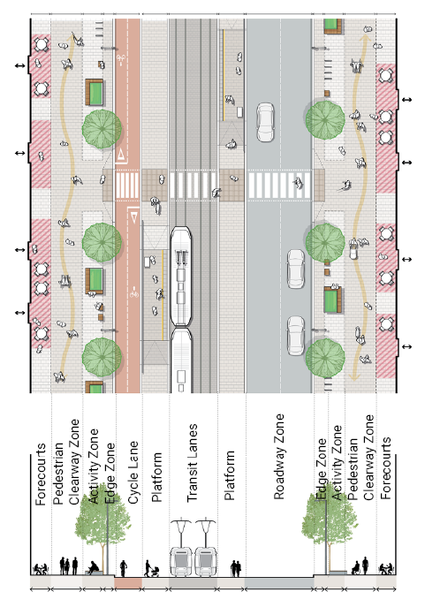
Figure 6: Accessible Transit Platforms

Degree of Sharing Streets

Intent
To provide guidance on how to create easy and safe movement of pedestrians, cyclists, and vehicles along streets at the waterfront, especially in conditions where all three groups may be sharing and using the same parts of the street at various times.

Degree of Sharing
The concept of the “degree of sharing” refers to the extent that pedestrians, cyclists, and vehicles share spaces or occupy space at any given time along the street.

The appropriateness of the degree of sharing must consider the following:
- Use of the street.
- Visibility along and across the street.
- Anticipated or known behaviour habits of the users.
- Volume of traffic and types of vehicles.
- Vehicle speed.
- Options for pedestrian crossings.

In general, when there is high degree of sharing on the street a series of built environment elements must be implemented to create a safe, accessible, and usable shared space for pedestrians, cyclists, and vehicle drivers.

Along the waterfront there are two key types of streets, the curbless street, and the curbed street. The section below outlines the key recommendations for the various conditions where curbless and curbed streets must be used.
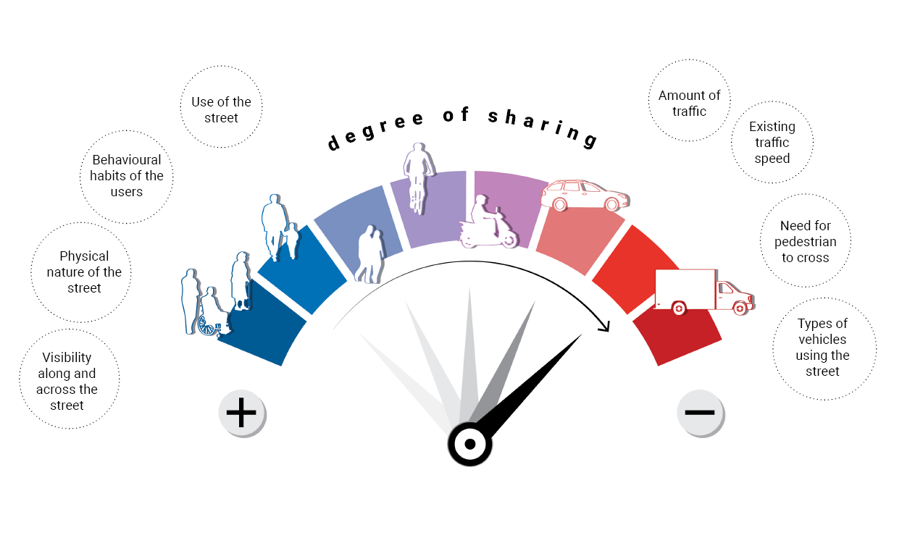
Figure 7: Degree of Sharing

Curbless Streets

- Provide curbless streets when the street is designated as a pedestrian area with limited vehicle access.
  - Vehicles must be limited to emergency and service vehicles.

- Prioritize pedestrian safety in curbless conditions.
- At entry points into curbless street zones the following must be provided.
    - Street signage that says, “Pedestrian priority zone; access limited to emergency and service vehicles”.
    - Removable bollards, planters or other barriers to limit vehicle access, prioritize accessible paths of travel, and identify the entrance to the shared street segments.

- Design distinguishable street surfaces.
- Where curbless street zones are used, they must have a different surface finish from curbed streets.
    - Where unit paving stones are used, they must be laid closely together, with minimal gaps. Each unit paving stone edge must be cut to be flat and not beveled, helping to create a smooth rolling surface. Providing a smooth and slip-resistant surface is critical to reducing the discomfort caused by vibrations when a person is constantly rolling over bumpy surfaces such as cobble stone surfaces or where ground upheaval has occurred.

- Enhance built environment cues to support a safe shared space between pedestrians, cyclists, and vehicle drivers.
- Colour contrast, material and textural cues must be provided to delineate pedestrian and vehicle paths of travel in these conditions.
- Tactile attention indicators must be provided to separate the pedestrian and vehicle paths of travel.
- Plantings and street furnishings may also be used to separate the pedestrian and vehicle paths of travel.

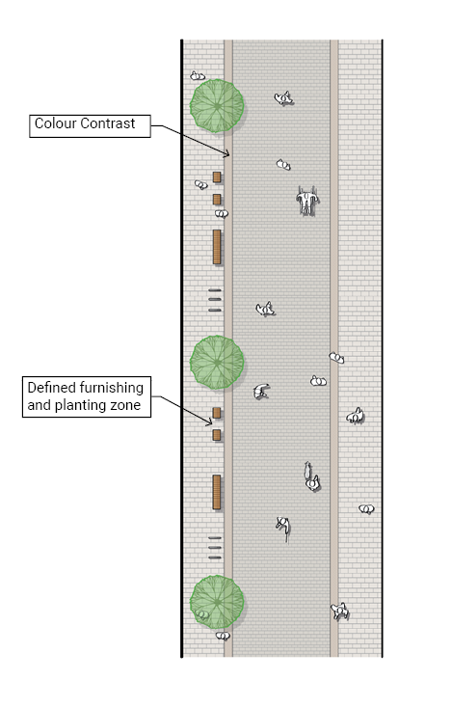
Figure 8: Curbless Streets – Scenario 1

Curbed Streets

- Provide curbed streets in all conditions where low to high vehicular traffic conditions occur regularly.
  - Increase enhancements for safety and accessibility where there is a greater anticipated amount of traffic.

- Low Flow Traffic Conditions: For streets that are shorter distances, have low speed traffic, and are considered residential streets, the following must be considered:
  - Curbs and pedestrian crossings must be provided as per the City’s construction Specifications and Drawings for Road Works.
  - Where on-street parking is provided, accessible parking spaces that connect directly to an accessible path of travel must be prioritized.

- Medium Flow Traffic Conditions: For streets that are shorter distances, have low to medium speed traffic, and are considered avenue and neighbourhood main streets, the following must be considered:
  - Curbs must be a minimum of 50 mm high.
  - Pedestrian crossing points must be provided a minimum of every 100 metres.
  - Pick Up and Drop Off Zones that connect directly to an accessible path of travel must be considered along the street where appropriate within the design, such as at accessible building entrances.
  - Where on-street parking is provided, accessible parking spaces that connect directly to an accessible path of travel must be prioritized.

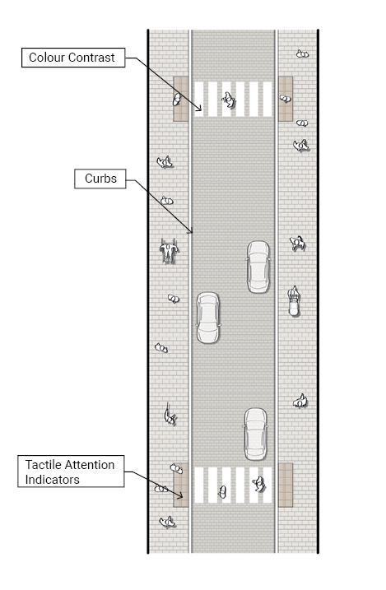
Figure 9: Curbed Streets – Scenario 2
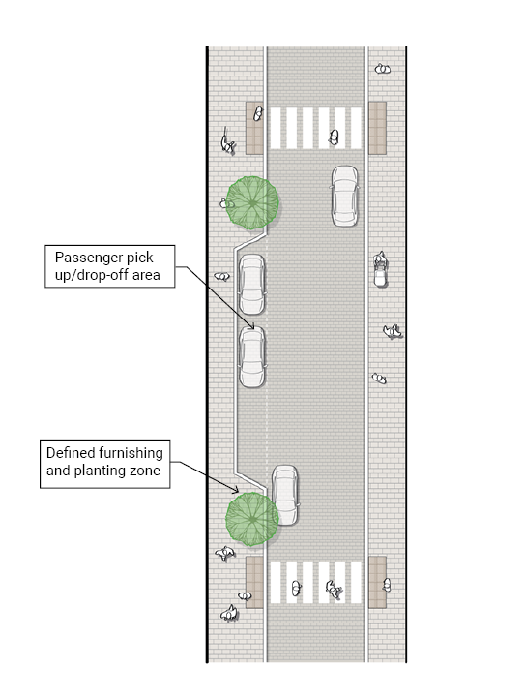
Figure 10: Curbed Streets – Scenario 3

- High Flow Traffic Conditions: For streets that are vibrant and mixed-use that are located in higher-density growth areas and support a wide range of land uses and activities, the following must be considered: (Within the context of the waterfront, these streets span the width of the Waterfront or continue north of the Gardiner Expressway, such as Queens Quay, Bay Street, Yonge Street, Lower Jarvis Street, and Parliament Street.)
  - Curbs must be a minimum of 100 mm high.
  - Raised pedestrian crossings must be provided every 100 metres, except where TTC streetcars are anticipated.
    - Provide tactile attention indicators on the pedestrian clearway where the raised intersection is provided at the pedestrian crossing.
  - Provide a curb ramp with tactile attention indicators where a pedestrian crossing is not raised and flush with the street level.
  - Pick-Up and Drop-Off Zones that connect directly to an accessible path of travel must be considered along the street, where supportive of the design.
- Drainage must be provided at curb ramps and pick-up and drop-off zones.

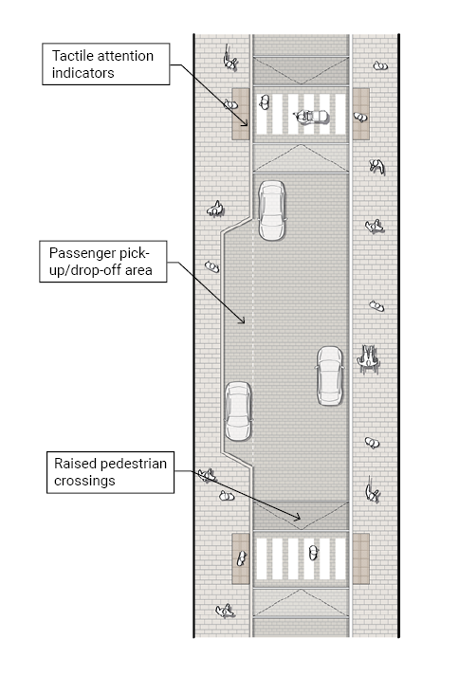
Figure 11: Curbed Streets – Scenario 4

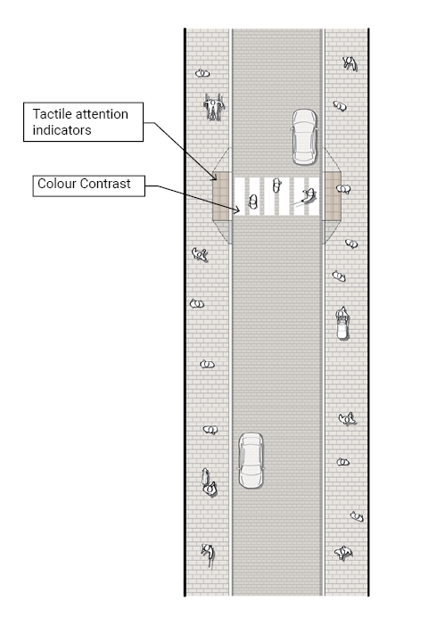
Figure 12: Curbed Streets – Scenario 5

Green Spaces

- Provide equal or equivalent experiences.
  - Where a range of terrains and elevation changes are provided in green spaces, any amenities, site furnishings and equivalent experiences must be provided in areas that are served by the accessible path of travel.

- Consider the relationship to other site amenities.
  - To support an enjoyable experience, provide nearby accessible amenities such as public use washrooms, drinking fountains or water bottle filling stations, access to public transit, and passenger pick-up and drop-off areas, wherever possible.

Dog Off-Leash Areas

- Use permeable animal turf or ground surfaces.
- Utilize surfaces that are stable and do not shift.
- Surfaces must be permeable, allow for drainage of animal waste, and be irrigated.
- Surfaces must not retain heat to reduce the risk of hot surface temperatures and burning paws.

- Provide paved accessible paths of travel.
- Accessible paths of travel must include an accessible entry gate at all entrance areas and connect to all amenities within the dog off-leash area.

- Provide accessible gates and entrance area.
- Gates must provide a minimum clear width of 1200 mm, with a minimum of 300 mm latch side clear space on the push side of the gate, and a minimum of 600 mm latch side clear space on the pull side of the gate.
- Gate opening devices or hardware must be operable using a closed fist.
- Where the gate doors into the vestibule are in series or are not aligned, a minimum clear turning space of 2500 mm must be provided that is clear of any gate door swing.
- A shelf must be provided within the entrance vestibule to the off-leash area.
- A cane detectable guard must be provided where the gate swings into the path of travel.
- Tactile signage, with both braille and raised text, should be provided on the latch side of the gate to identify the area as an off-leash space.

- Provide accessible amenities in the off-leash area.
- Water supply, waste receptacles, and poop bag dispensers must be provided:
    - Mounted between 900 mm to 1100 mm above the finished floor.
    - Operable using a closed fist.
    - Located near the entrance of the dog off-leash area.
- Rest areas that comply with TADG, Rest Areas (1.1.5), and Benches and Seats (1.5.1) must be provided within the dog off-leash area.

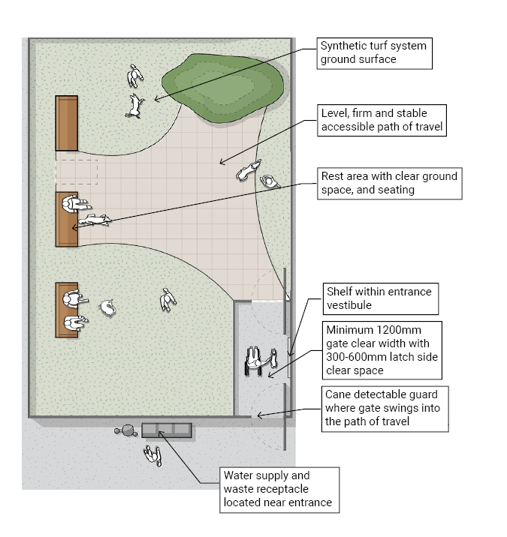
Figure 13: Dogs Off-Leash Areas

Outdoor Play Spaces

- Provide opportunities for structured and unstructured play.
- Open spaces and play structures must be considered in developing outdoor play areas. Both spaces must consider the range of physical abilities children have and allow for accessible play opportunities while creating physically challenging environments.

- Provide opportunities for sensory play.
- Consider zones that allow for the delight of a variety of human senses from sight, hearing, touch, to smell.

- Provide opportunities for collaborative play.

- Provide opportunities for quiet play.
- Consider zones that allow for a break from the activity and allow for an opportunity to decompress.

- Provide spaces for caregivers.
- Caregivers and parents accompanying children may also have a disability. Provide opportunities for seating for caregivers.
- Spaces must be served by accessible paths of travel to allow groups of people to come together, including caregivers.

- Consider the relationship to other site amenities.
- To support an enjoyable experience, consider providing accessible amenities nearby, such as public use washrooms, drinking fountains or water bottle filling stations, access to public transit, and proximity to pick-up and drop-off areas.

Amphitheatre Seating

- Stairs that serve as the path of travel must be distinct from the tiered seating.
- Avoid design strategies that attempt to combine multiple functions such as seating, accessible paths of travel, ramps and stairs also known as “stramps”, “hangout steps”, or “angled steps”. The path of travel served by stairs, must be clearly demarcated from the tiered seating area by:
    - Providing handrails on a minimum of one side of the stairs.
    - Providing risers and runs as per the Accessibility for Ontarians with Disabilities Act, Design of Public Spaces Standards.
    - Having a colour contrast or a distinctive visual pattern to demarcate the leading edge of the tread and landing.
    - Providing tactile attention indicators at the top of the stairs.

- Integrate clear ground space for persons using mobility devices or for persons with service animals.
- Clear ground spaces must be provided in a variety of locations and with a variety of viewing areas. Clear ground spaces must not be limited to the top or the bottom of the amphitheatre.
- Accessible paths of travel must be provided to a mid-tier section of the amphitheatre seating and provide clear turning spaces that are a minimum of 2500 mm.

- Provide a variety of seating heights.
- Provide a variety of seating heights throughout the amphitheater that allow for clear sightlines to the intended viewing area. Persons of short stature and children would benefit from having lower seating heights, and persons who have difficulty getting up and down from their seat would benefit from higher seating heights.

Lighting

- Lighting must be provided at the pedestrian scale.

- Use lighting to further improve visibility, including for any tripping hazards, areas of safety concern, the edge of the boardwalk, or changes in level.

- All lighting must have directional filters (lens) to avoid light shining into people’s eyes at a variety of height levels.

- Lighting must be directed to the ground surface or the element of focus, such as signage, or user controls.

Wayfinding and Navigation

- The following must be considered as components of wayfinding:
  - Use of tactile direction indicators.
  - Use of sound beacons that provide audible cues for navigation.
  - Use of lighting along primary accessible paths of travel.

- Wayfinding and navigation strategies must begin at public transit, passenger pick-up and drop-off zones, and accessible parking spaces and continue along accessible paths of travel to key destinations and amenities.

- At signalized pedestrian crossings, a sign consisting of the Dynamic Symbol of Access, and tactile and written directions must be post-mounted between 1200 mm to 1500 mm above the finished floor.
  - Tactile and written directions must include:
    - The street name that the person is crossing towards and, if applicable, the major landmark.
    - Braille, and raised text that has character height sized appropriately to the intended viewing distance and colour contrast.

- Work with technology solutions to map the accessibility features along the waterfront.
  - Partnerships with organizations should be leveraged to help communicate the accessibility and usability of a site for persons with a range of disabilities. During project development, the range of accessibility features should be documented and verified upon completion.

Outdoor Furniture

- Provide eating and picnic areas that comply with TADG, Exterior Eating and Picnic Areas (1.4.4).

- Provide benches and seats that comply with TADG, Benches and Seats (1.5.1).

Public Use Washrooms

- Provide single occupancy washrooms for public use.
  - Provide a water closet, lavatory, and washroom accessories within single occupancy washrooms to ensure the highest level of privacy and gender inclusion.
  - Where more than one single occupancy washroom for public use is in proximity:
    - A minimum of 20%, but never less than one, must be designed to be accessible.
    - A minimum of one must be designed to be ambulatory.
    - A minimum of one must provide plumbing fixtures and washroom accessories that are installed at heights to accommodate the needs of people of shorter stature.

- Where gender designated multi-stall washrooms for public use must be provided, water closet stalls or enclosures must provide full-height partitions to ensure the highest level of privacy.

Appendices

Waterfront Advisory Committee on Accessibility
The Guidelines were developed in collaboration with Waterfront Toronto’s Advisory Committee on Accessibility and initially published in draft form for public feedback. The Waterfront Advisory Committee on Accessibility (ACA) consisted of 13 representatives of advocacy organizations and individuals with relevant expertise, most of whom were persons with disabilities as defined by the Accessibility for Ontarians Disabilities Act. The ACA provided guidance, direction, feedback, and advice to Waterfront Toronto as the Guidelines were drafted.

The ACA members included:

- Alison Novak
- Amanda Karahanas
- Bernard Akuoko-Dabankah
- Bruce Drewett
- Darren Cooper
- David Dame
- Howard Gerry
- Jutta Treviranus
- Luke Anderson
- Riley Ambrose
- Sarah Manteuffel
- Talli Osborne
- Tim Archer

The ACA’s contribution to the development of these guidelines was instrumental in shaping how Waterfront Toronto moves forward with the development of new projects and consults with the disability community during the design process.

Waterfront Accessibility Advisory Committee
To support the effective implementation of these Guidelines, Waterfront Toronto is forming the Waterfront Accessibility Advisory Committee. This new Committee provides feedback, guidance and advice to Waterfront Toronto and its design consultants on the design and delivery of public realm projects.

The mandate of the Committee is to apply the principles and technical requirements of the Guidelines, as well as lived experience, and advocate for accessible and inclusive public spaces on the waterfront where everyone is welcome and encouraged to participate.

Public realm projects being led by Waterfront Toronto, including new construction and projects that have reached the end of their lifecycle or require upgrades, are reviewed by the Committee early in the design process (i.e., Schematic Design Phase) and additionally, if required. The Committee’s comments are also shared with the Waterfront Toronto Design Review Panel during its review of projects.

The Committee is composed of 6-8 members who represent advocacy or professional organizations, and individuals with relevant expertise, most of whom are persons with disabilities, as defined by the Accessibility for Ontarians with Disabilities Act.

Feedback Process
Knowing that standards and practices evolve over time, Waterfront Toronto will review and update the Guidelines on a regular basis, at minimum every three years. This review will consider lessons learned through implementation, advancements in accessibility practices or research, any new features or interventions that ought to be considered at the time, as well as any feedback that has been received since the last update. Feedback can be sent at any time to Waterfront Toronto either by emailing info@waterfrontoronto.ca or by regular mail at the address below. Please include the following information:

- Name
- Company/organization (if applicable)
- Address (or Postal Code)
- Contact information
- A description of the proposed change, including the applicable section of the Guidelines, new or revised wording, new considerations, etc.
- Rationale or explanation for the recommended change

Attn: Accessibility Design Guidelines
Waterfront Toronto
20 Bay St., Suite 1310
Toronto ON
M6J 2N8

